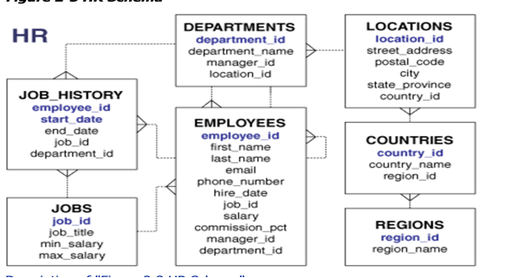

1. Find employee last_name , and salary who were hired before 10- Oct-2020;

Select last_name, salary

From employees

Where hire_date < 10 -Oct-2020;

2.Find employee last_name , salary, and department_name who’s salary is higher than 90,000.

Select employees.last_name, employees.salary, departments.department_name

From employee

Inner join departments

On employees.department_id= departments.departments_id

Where salary > 90000;

3. Find employee last_name , salary, job title and start-date

Select employees.last_name,employees.salary,jobs.job_tittle,job_history.start_date

From employees

Inner join job_history

On employees.employee_id=job_history.employee_id

Inner join jobs

On jobs_history.job_id = jobs.job_id;

4. Find employee last_name , department_name ,street address and country_name

Select employees.last_name, departments.department_name, locations.street_address, countries.county_name

From employees

Inner join departments

On employees.department_id= departments.department_id

Inner join locations

On departments.location_id=location.location_id

Inner join countries

On locations.country_id=countries.country_id;